|  |  |
| --- | --- |
| **Midterm Exam 20221**  **STT**  Subject: IT3290E – DatabaseLab Group: 4  Date: Dec 8, 2022 Duration : **60 min** | |
| Student ID: 20205194  Student Name: Nguyễn Thị Phương Thảo | **Note:** |

**For each question, copy your query and its result including the status bar (print screen)**

Example: List all customers

select * from customers

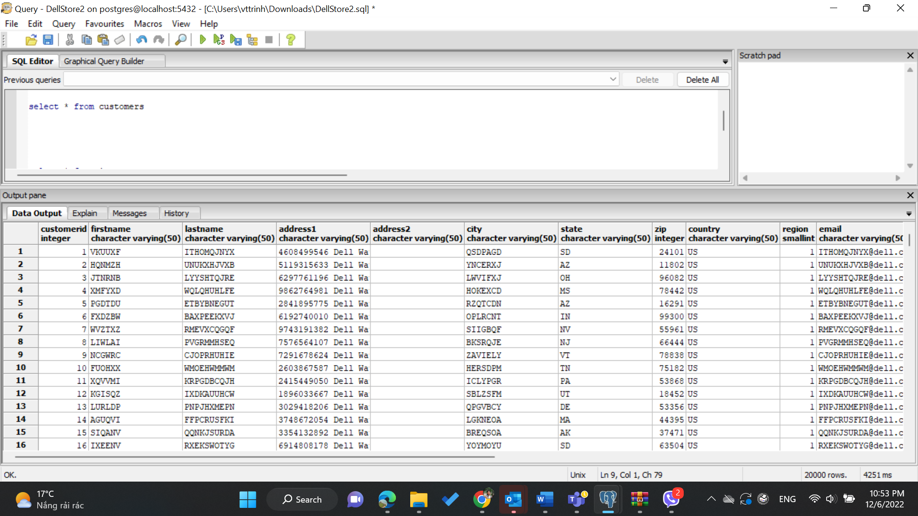

* 1. Display the list of Orders in the order starting with the newest order (… the oldest ones)

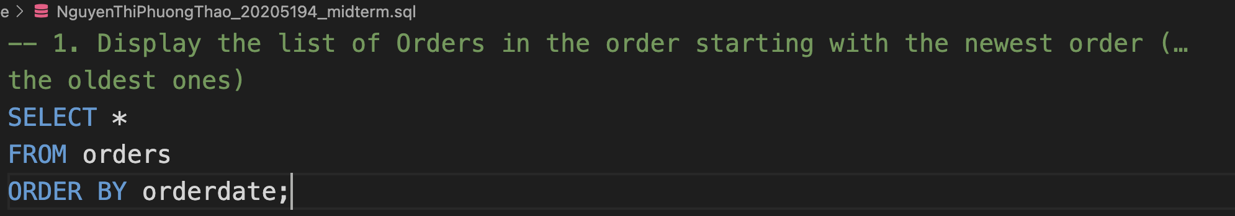

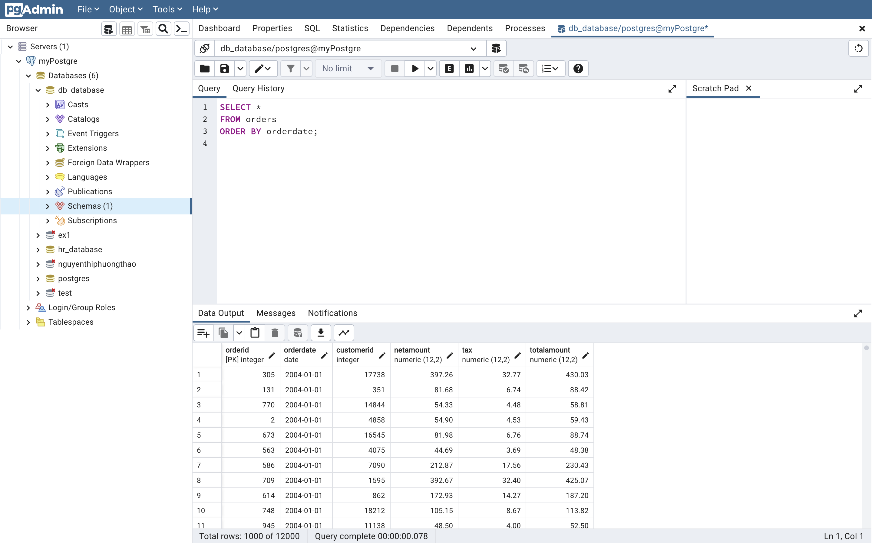

* 1. Display the list of products and its quantity in stock (inventory) in ascending order of quantity in stock

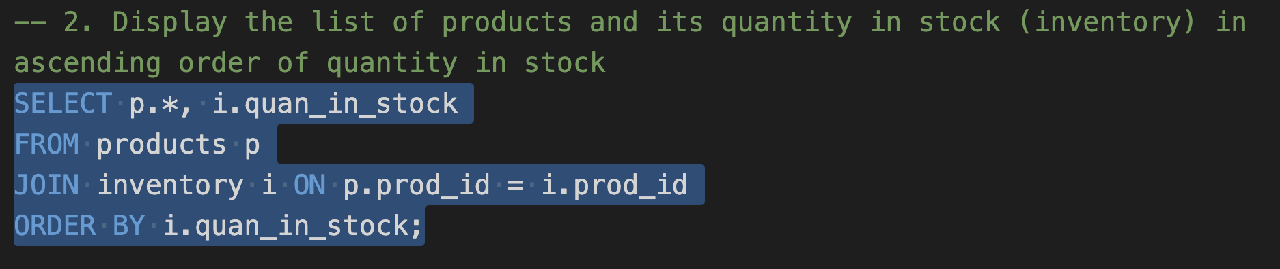

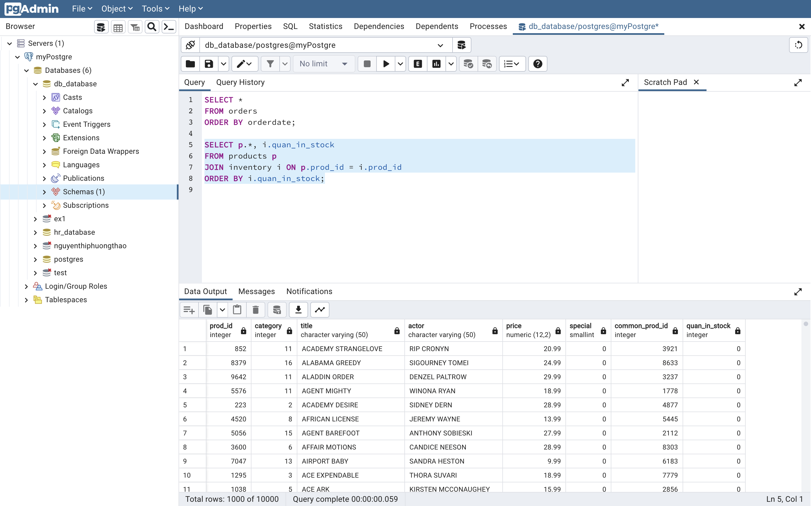

* 1. Convert credit card expiration (customers.creditcardexpiration) into datetime data type. By default, expiration day is 1st day of month

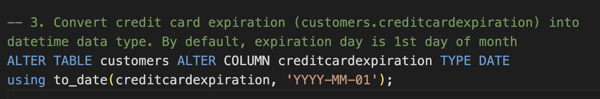

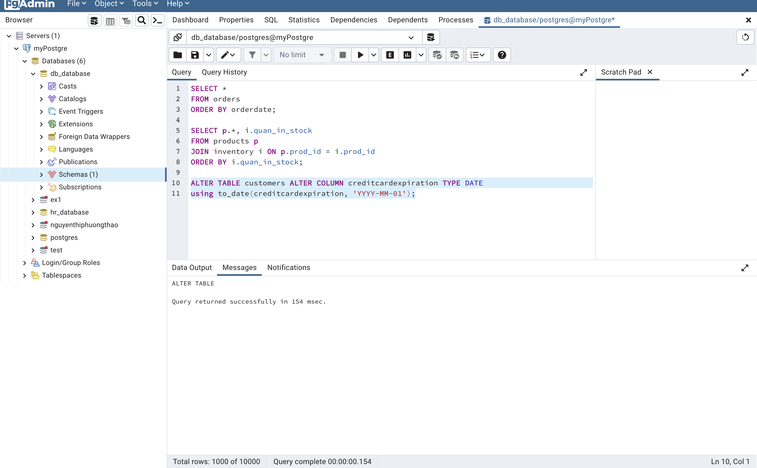

* 1. Display the total value of all orders of each customer

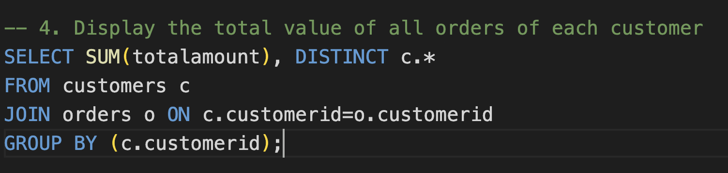

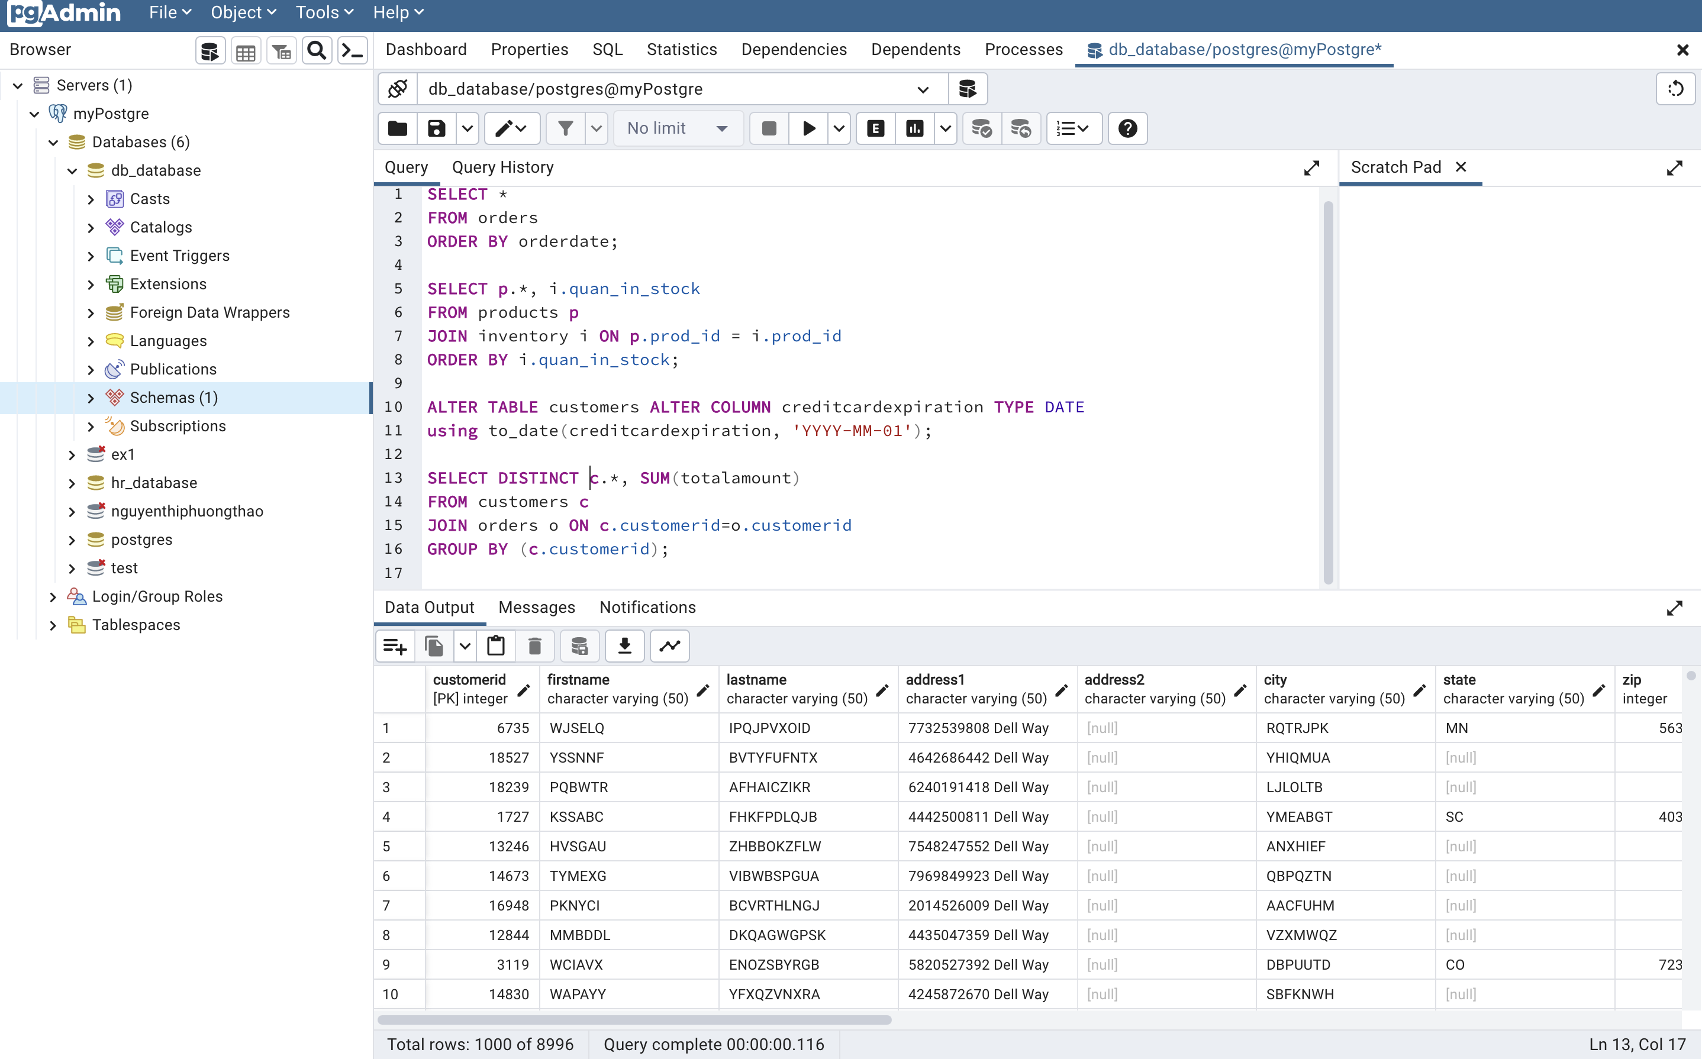

* 1. Display the list of categories and the total amount of orders for each category (in case no order, the total amount will be zero)

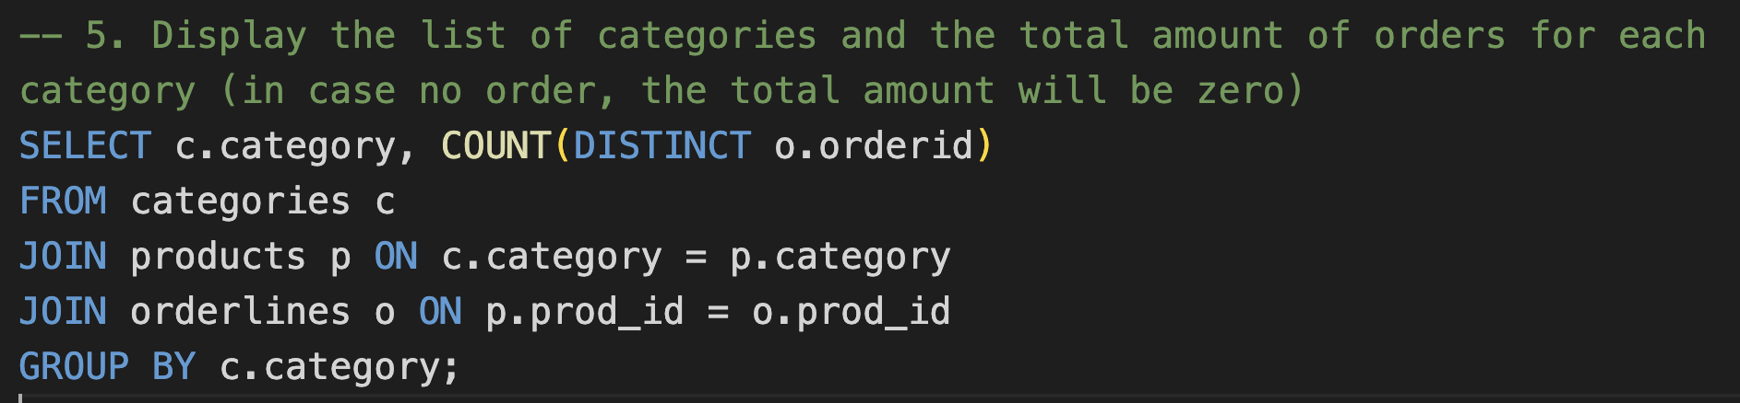

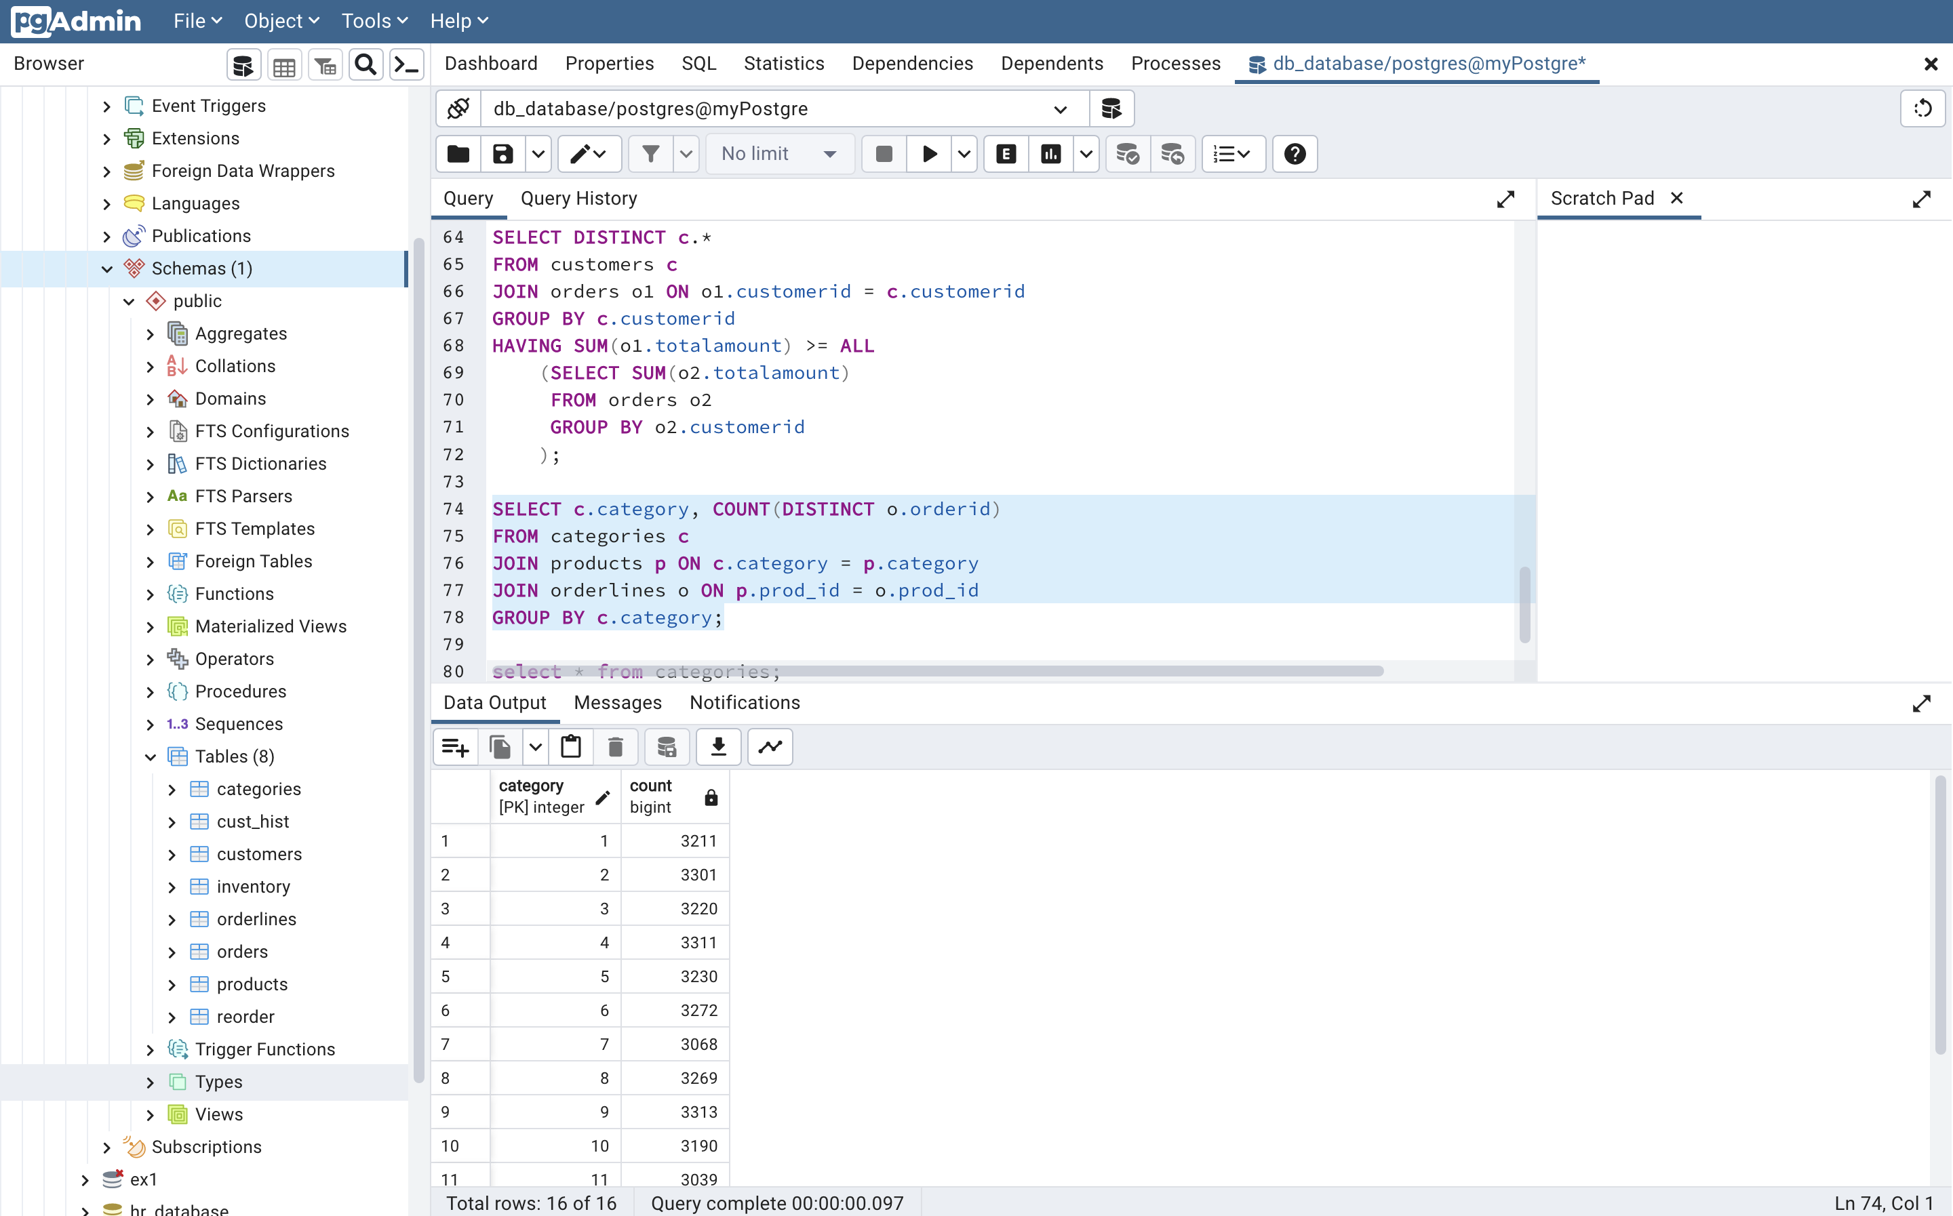

* 1. Display the list of categories appeared in the order(s) on Dec 31, 2004

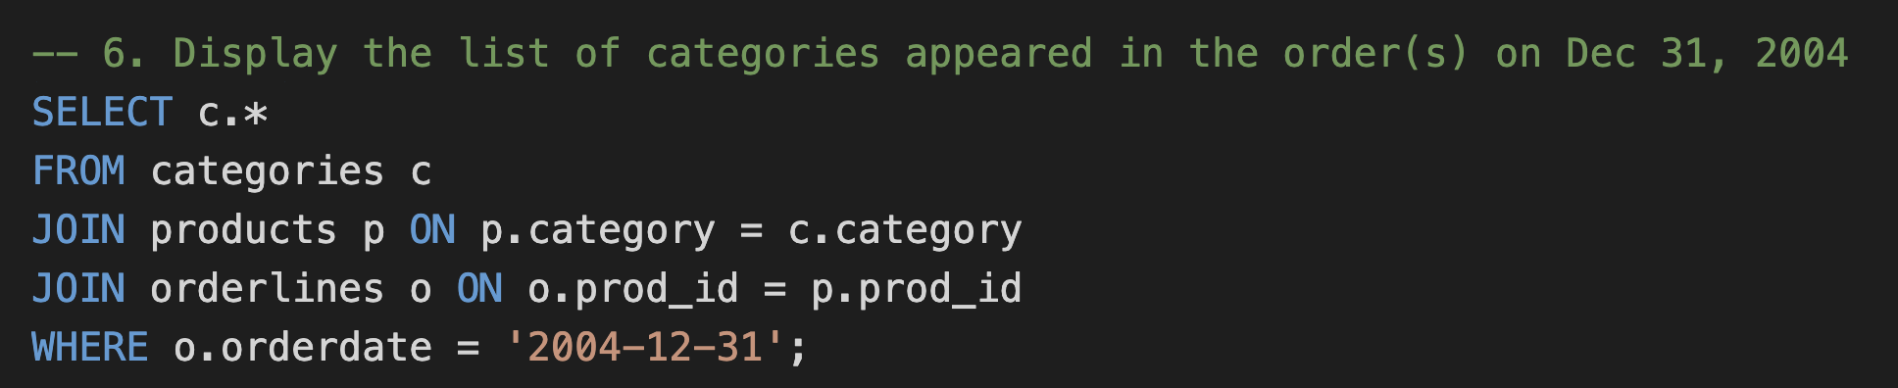

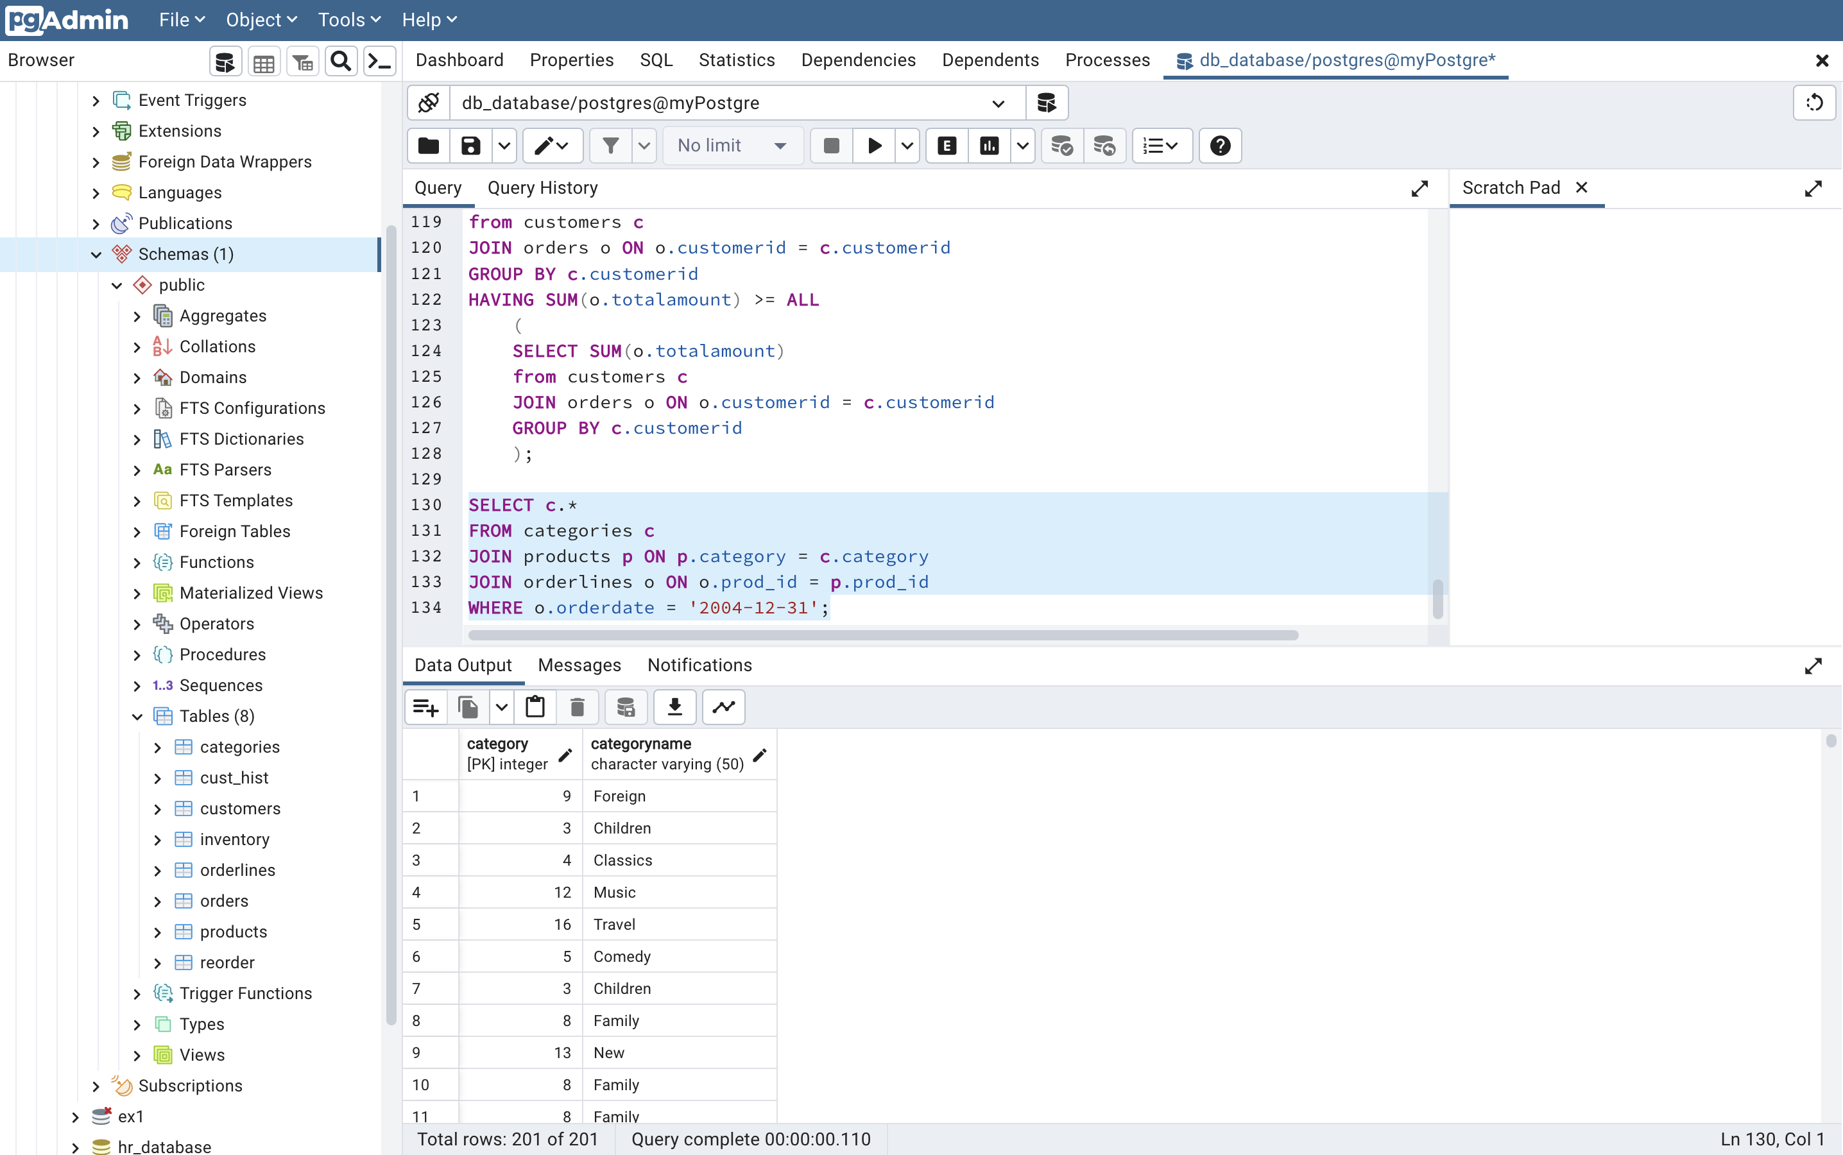

* 1. Delete all customer who live in the VT state

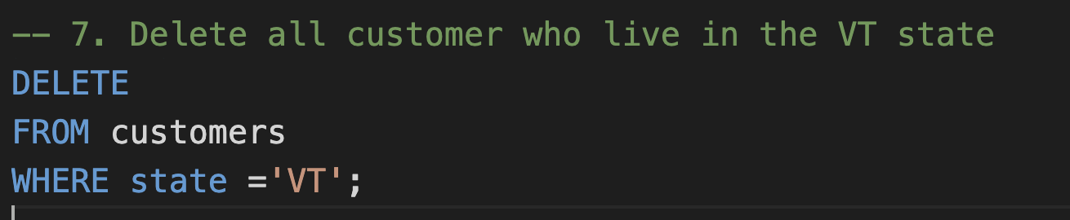

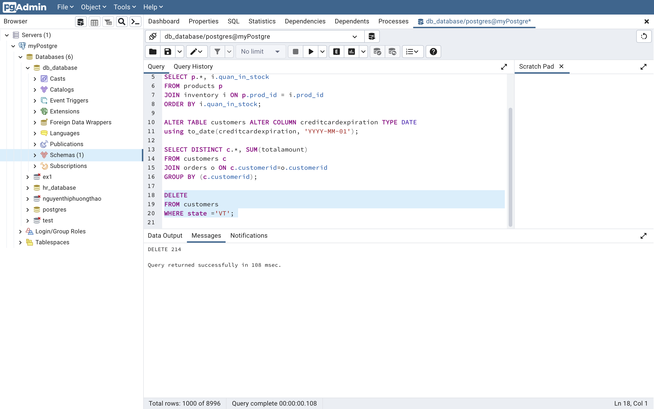

* 1. Do you have any comment/remarks on the previous query (number 7)

Before using modifing queries like DELETE we have to check the conditions in the WHERE clause carefully as it can delete, update wrong/undesired rows, especially PRIMARY KEY and FOREIGN KEY

* 1. Display the list of customers whose credit card is expired in June 2011

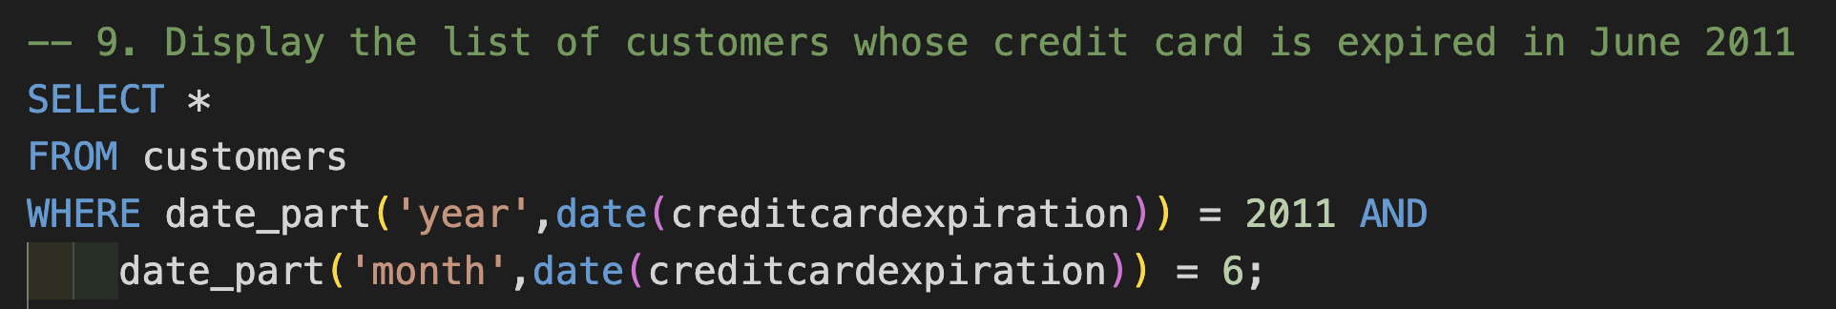

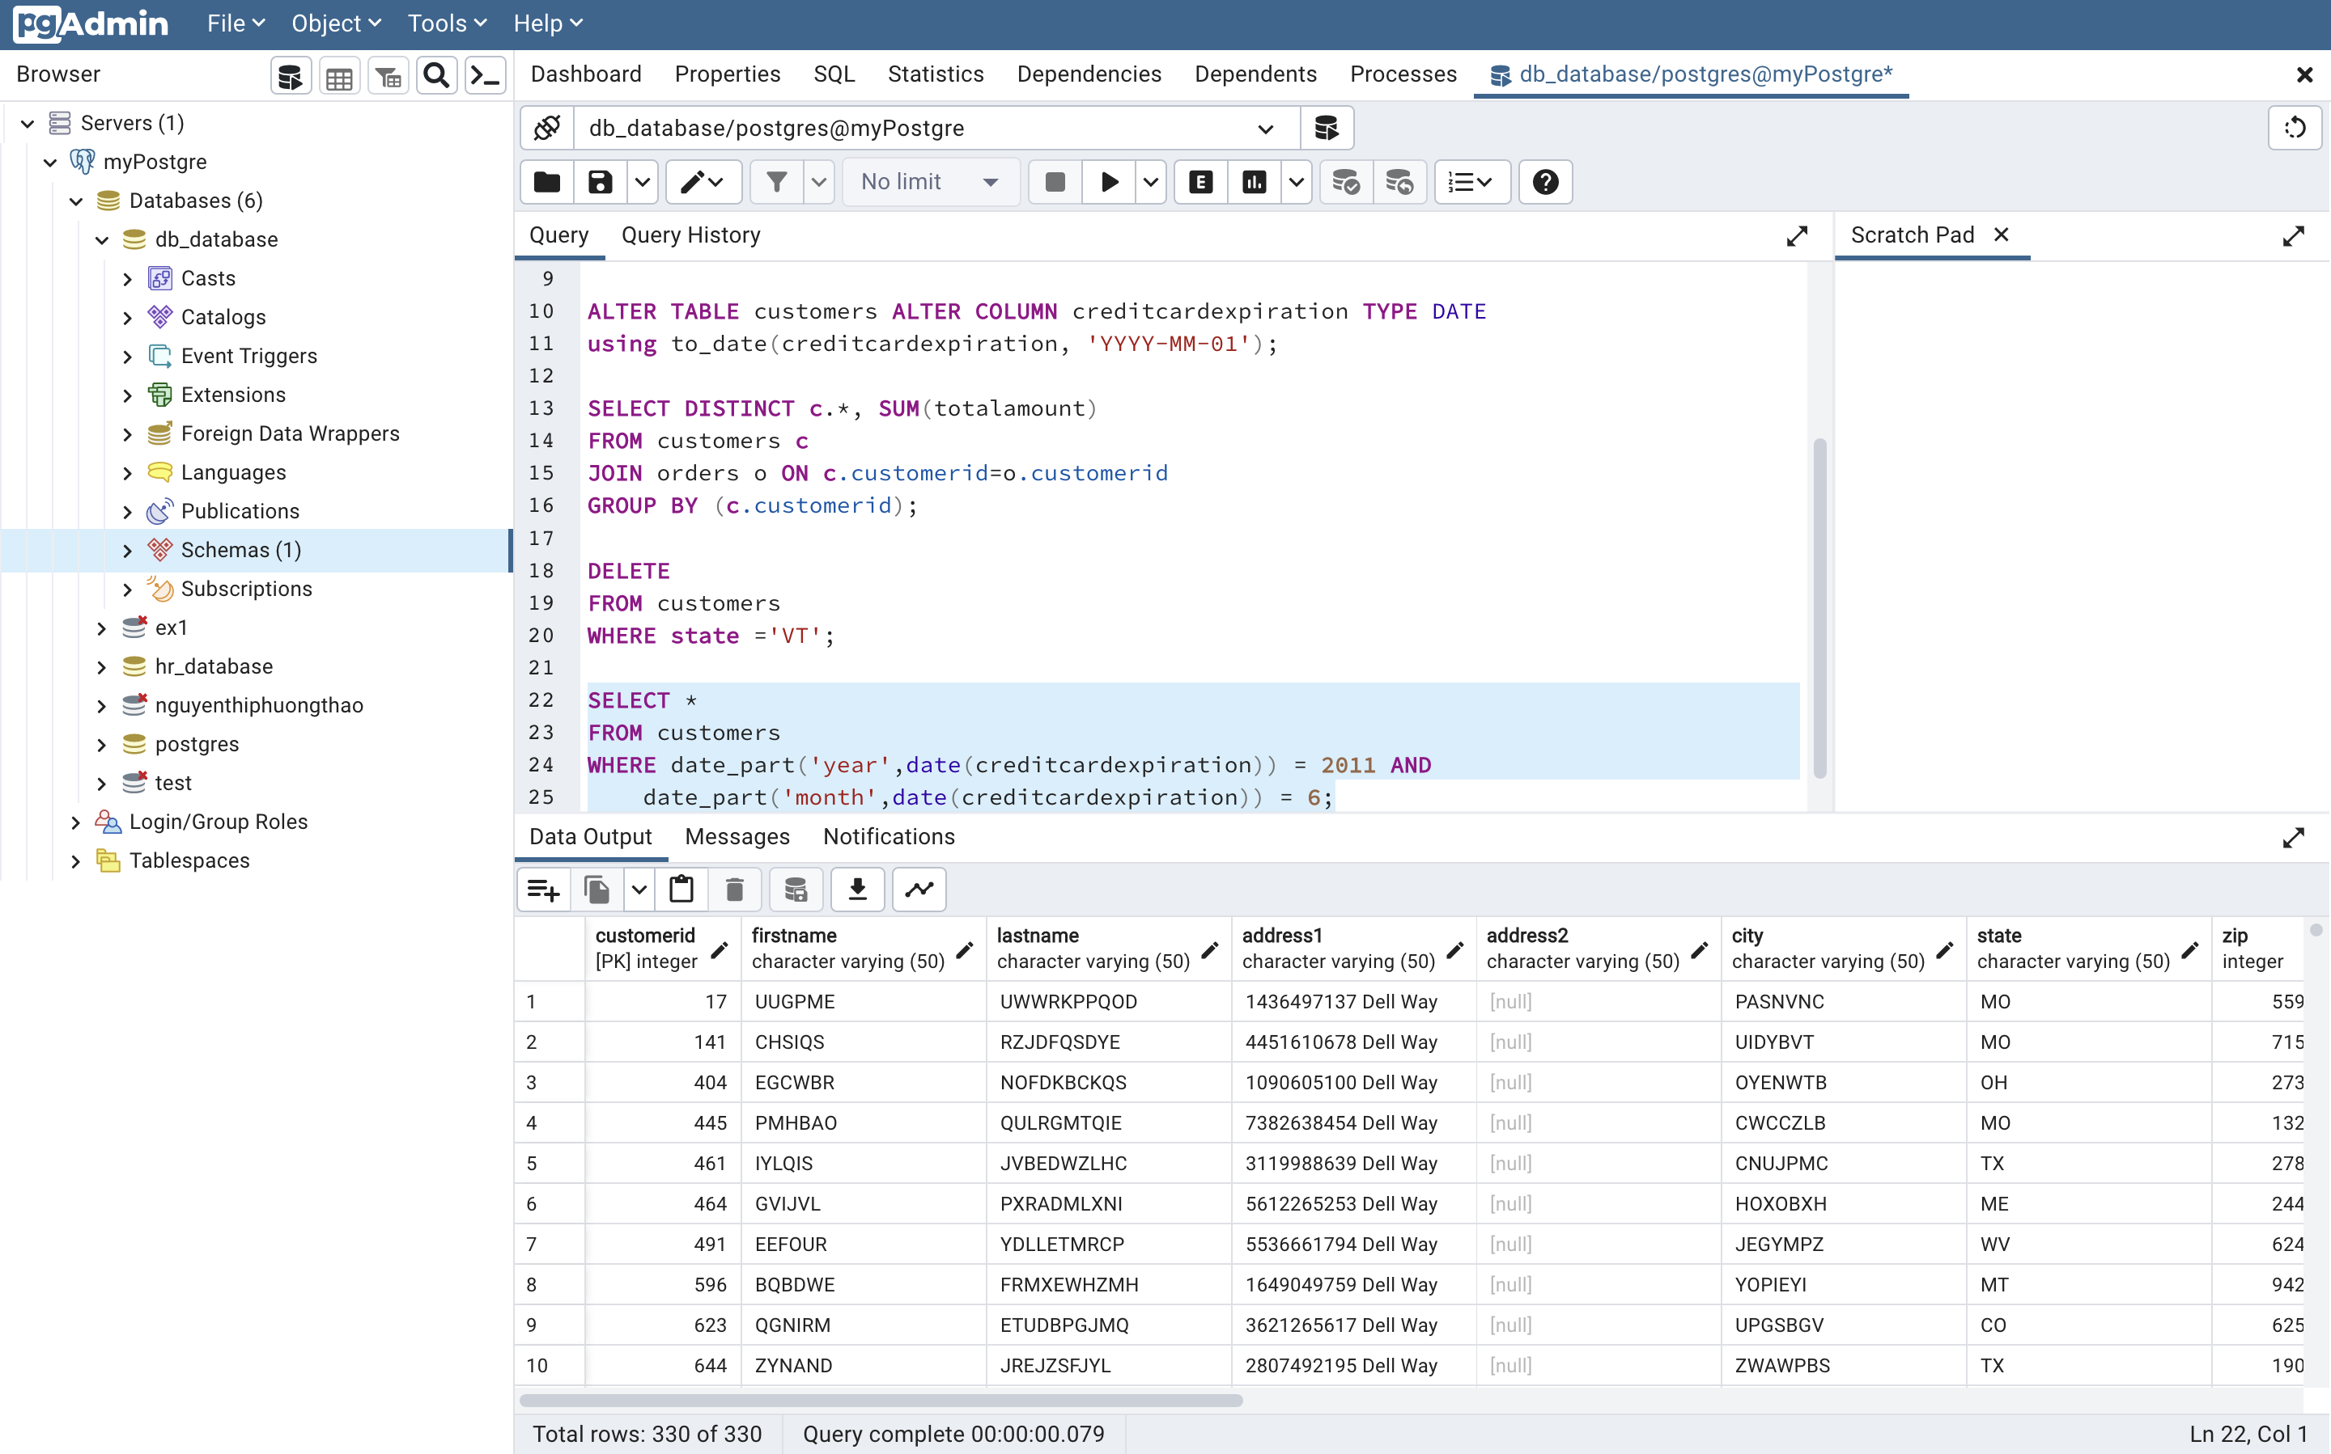

* 1. Display the list of customers, their firstname has at least 2 characters “A”

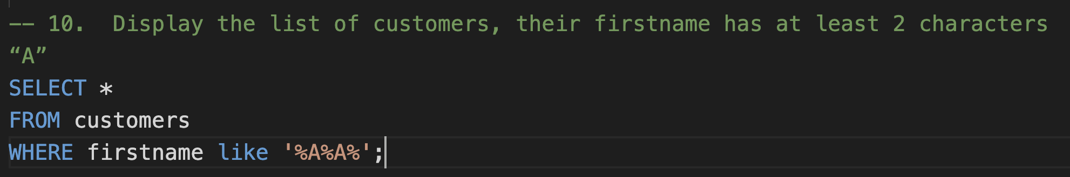

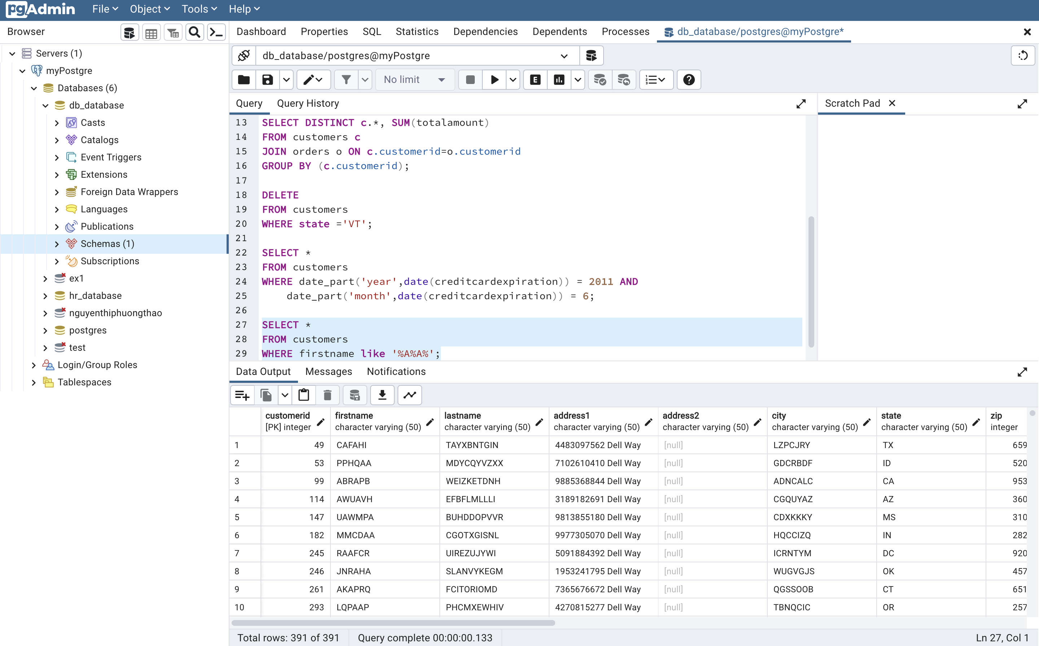

* 1. Display the list of products and the total ordered quantity of each product per month. The list is in alphabetical order of product name

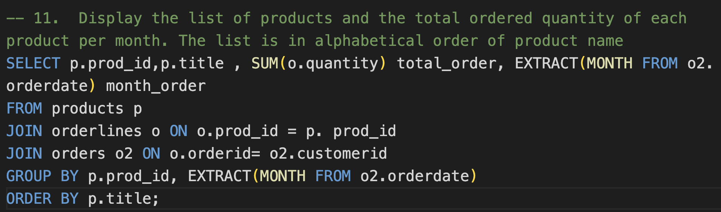

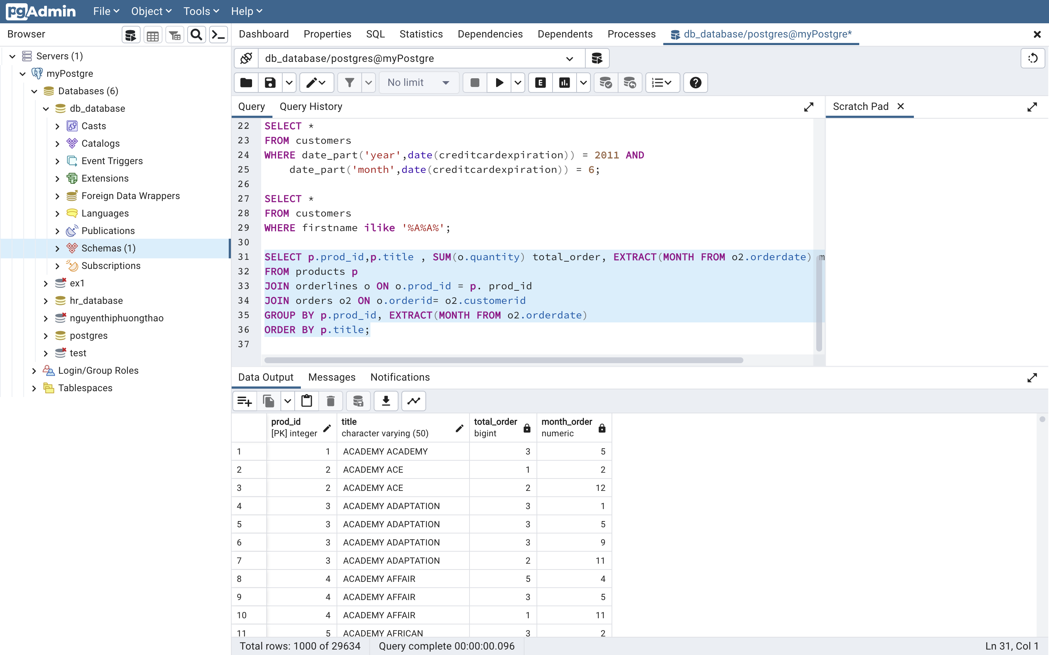

* 1. Display the list of customers having the greatest total amount of their orders

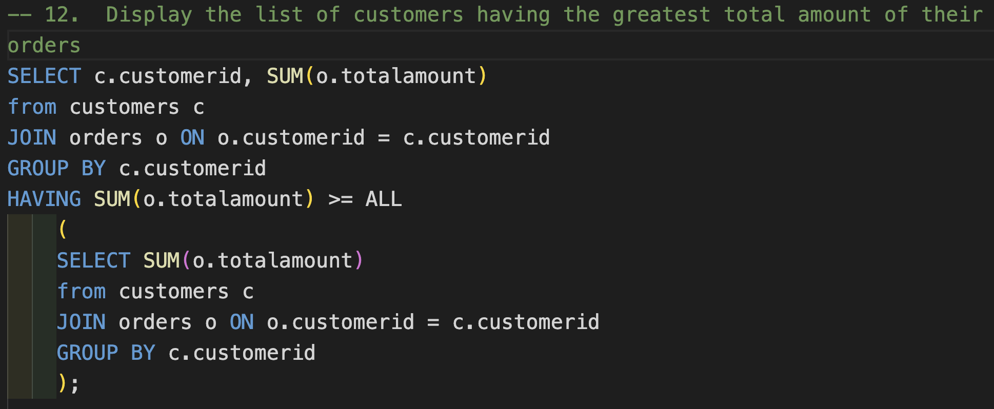

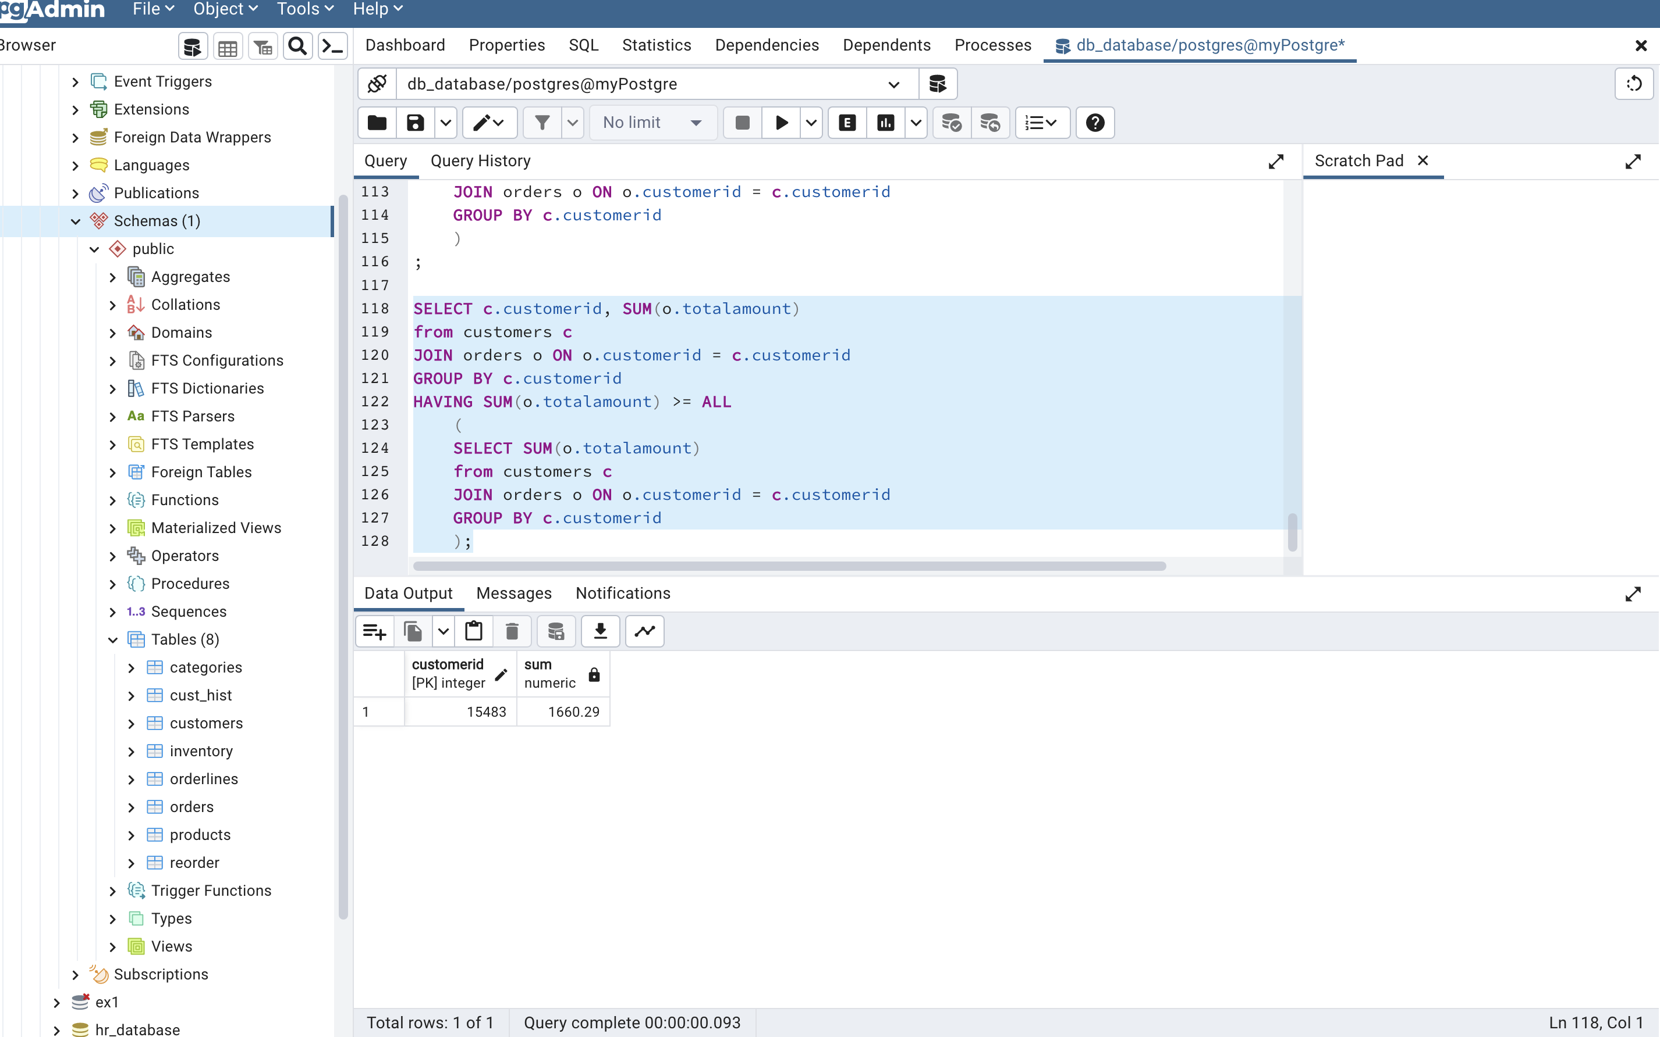

* 1. Display the list of products having the total ordered quantity greater than the quantity in stock

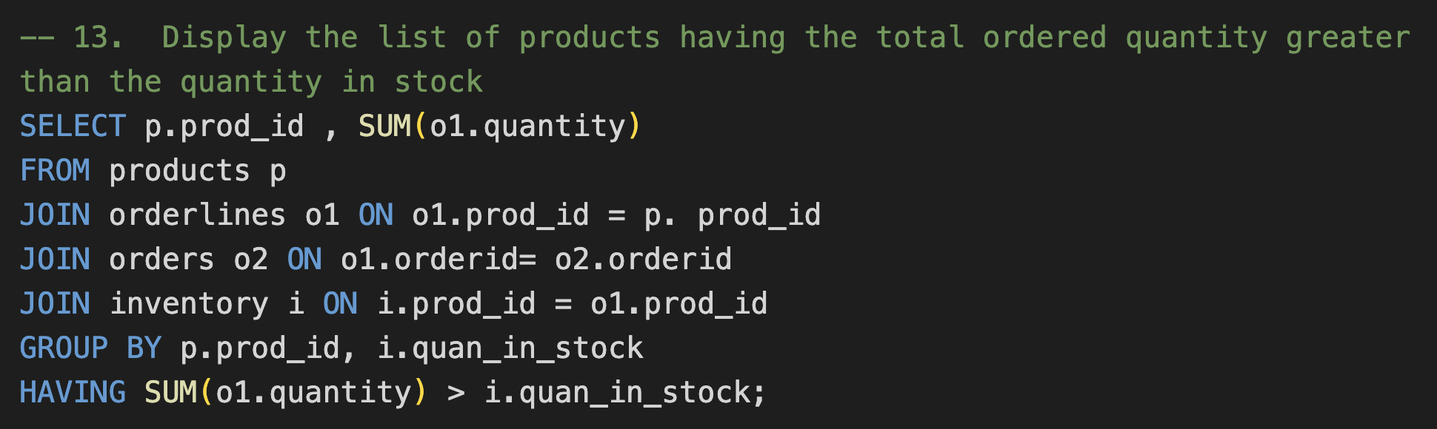

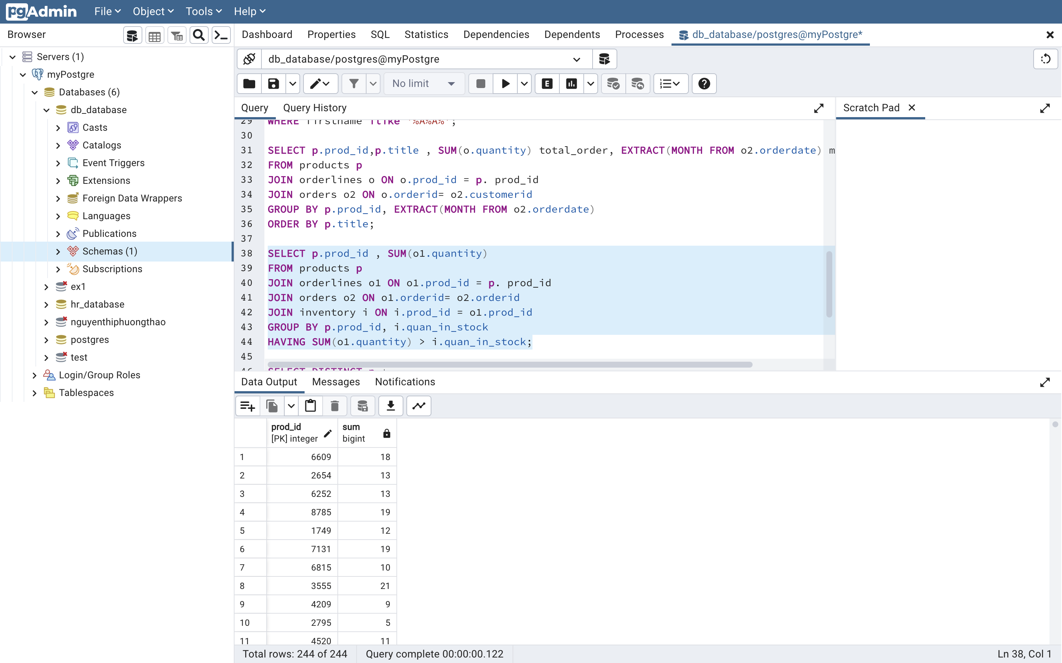

* 1. Display the list of states and the number of customers in each state if it is greater than 200

